Lab 3: Basic Object-Oriented Techniques

**Part 1: Branch your repository:**

<working on github>

**Part 2: Working with method overloading**

* addDigitalVideoDisc(DigitalVideoDisc [] dvdList)

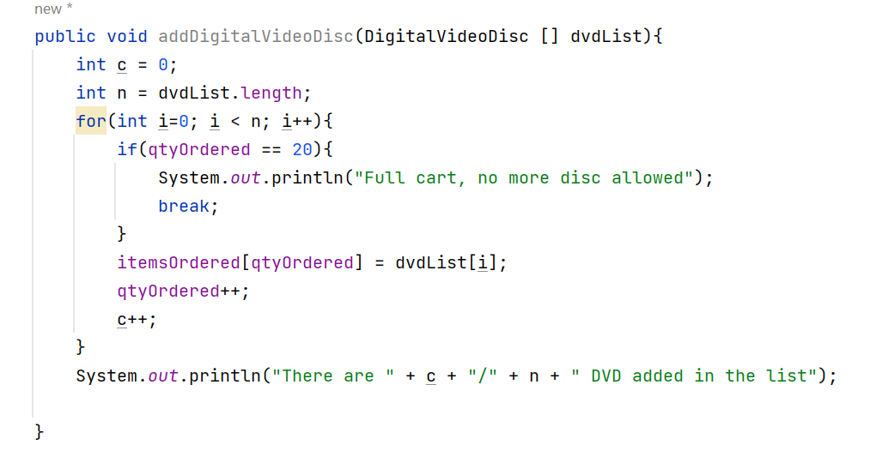

* addDigitalVideoDisc(DigitalVideoDisc …dvdList)

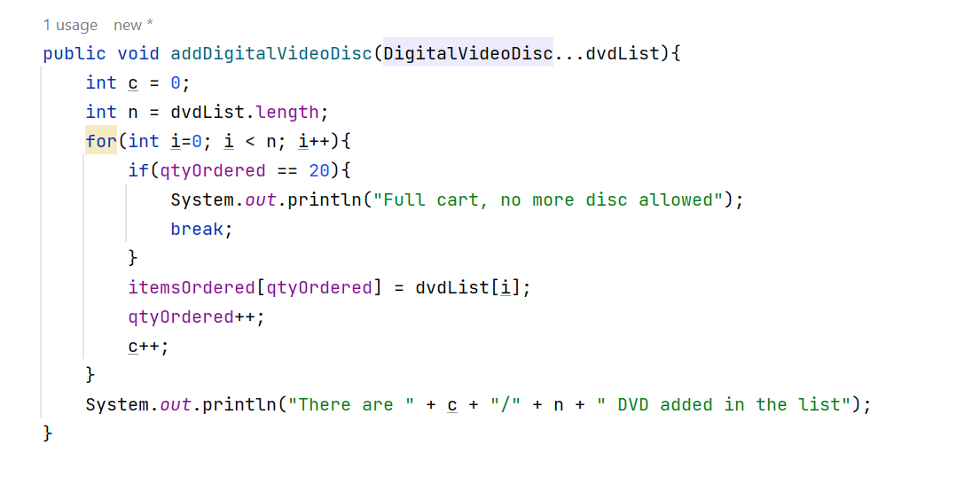

* addDigitalVideoDisc(DigitalVideoDisc dvd1, DigitalVideoDisc dvd2)

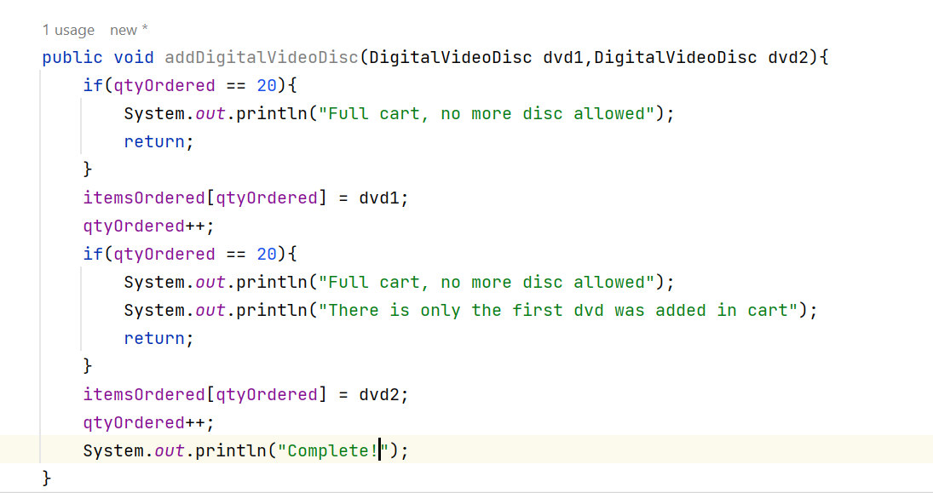

**Part 3: Passing Parameter:**

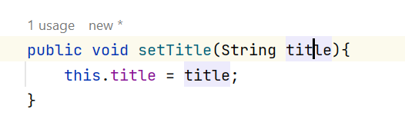

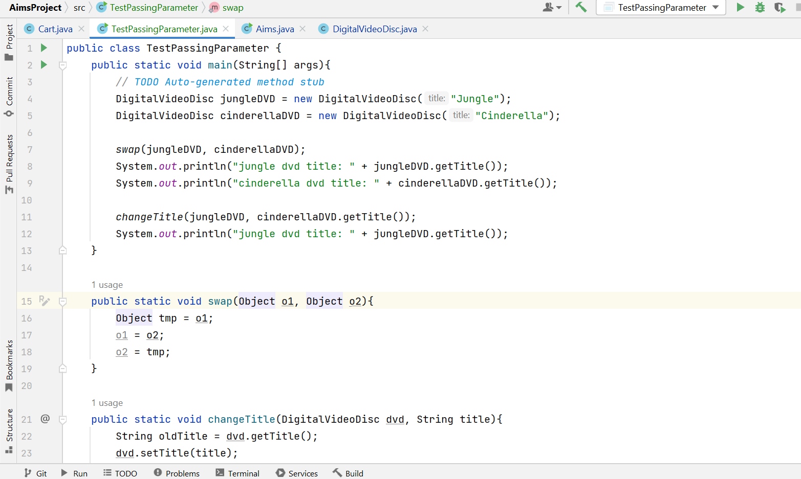

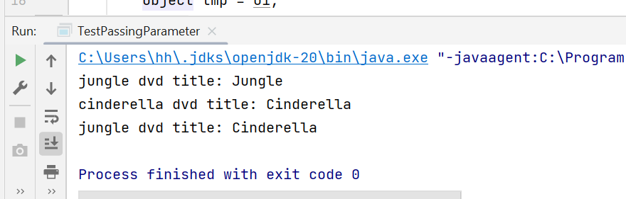

* swap() method that can correctly swap two objects:

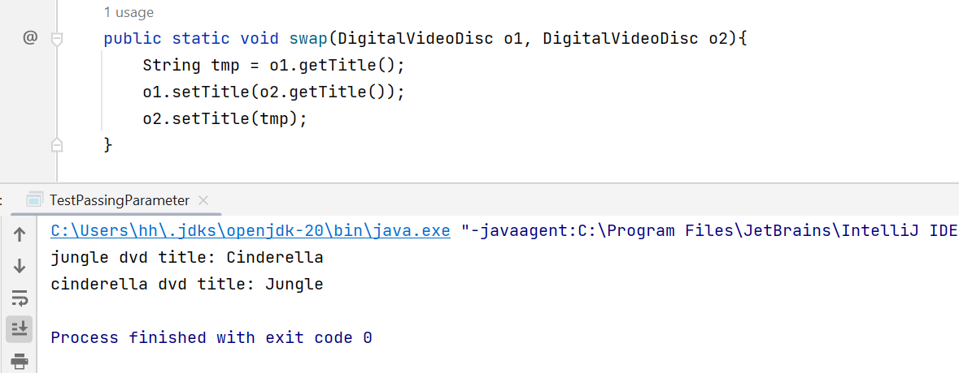

**Part 4: Use debug run**

<only need to follow the handout>

**Part 5: Classifier Member and Instance Member**

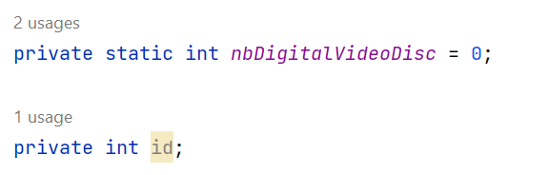

**Part 6: Open the Cart class: create printTheList()**

* printTheList() method

* 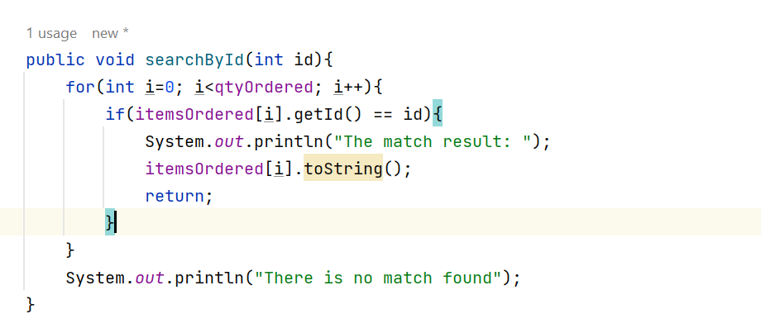searchByID() method

* searchByTittle() method

**Part 7: Implement the Store class**

* Create Store class:

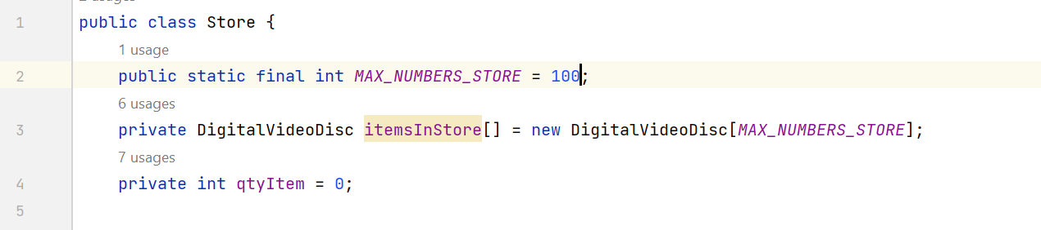

* Add and remove:

**Part 8: Re-organize your projects:**

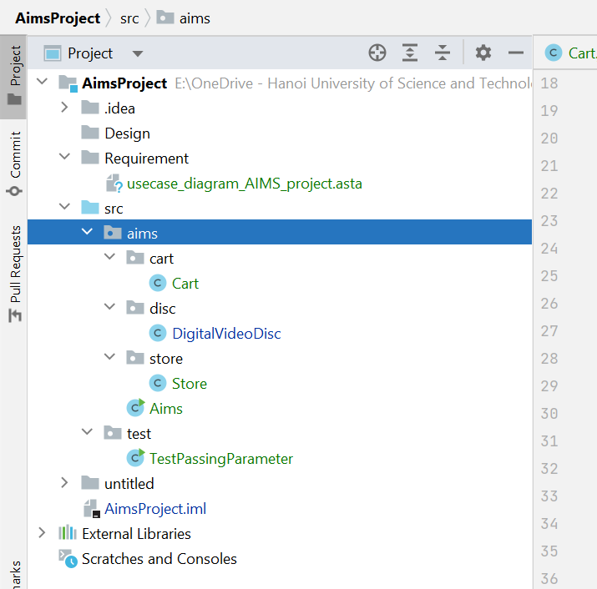

**Part 9: String, StringBuilder and StringBuffer**

* ConcatenationInLoops

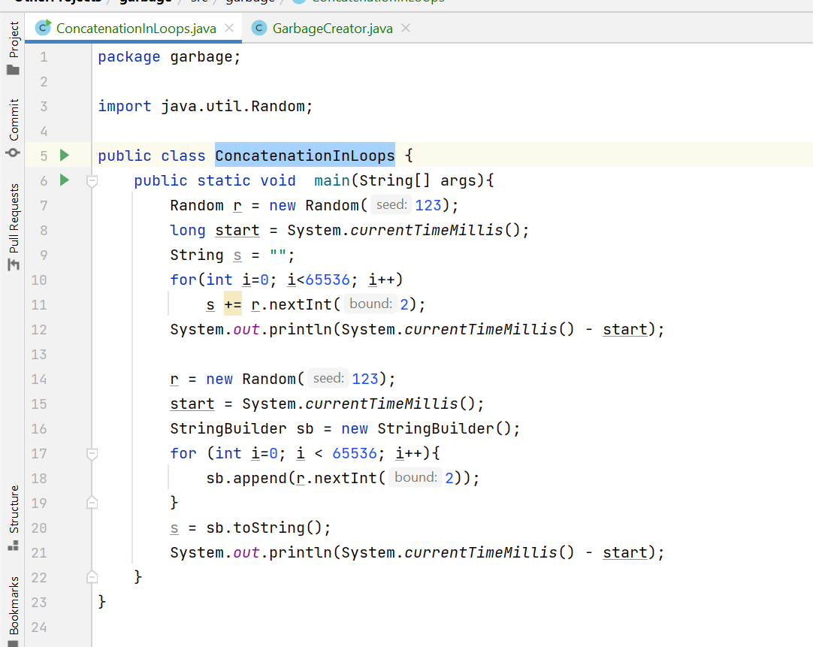

**Part 10: Release flow demostration**

* Check the github for the result of branching and others